FlipKart

Danny Song, Ting Ting Xu, Jin-Han Han

Team 3

CS157a Section 1

**Project Description:**

This project will create a worldwide online shopping website to support e-commerce service. It provides an electronic retail and business platform for registered users to purchase and sell products. This electronic platform will replace the typical online shopping website. It will provide small business or individuals an easier way to post and sell their products, and also serves buyers a more fast and simple way to finish payment transaction. It will become the mainstream online shopping system in the United State and overseas The stakeholders will be 77 billion people worldwide, those people including retail suppliers, entrepreneurs. This platform will provide users a simple, fast, and secure e-commerce site.

**System Environment:**

This ecommerce site will be designed to run within the clients browser and thus the GUI will be created using HTML, CSS. The web server will be handled using Apache Tomcat and thus will be developed using Java EE. This Tomcat server will provide the client with the GUI as well as connect them to the database which will use MySQL as its database management system. The Tomcat server will communicate with the MySQL database through JDBC. 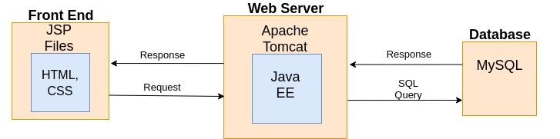

**Hardware and Software Used:**

* Hosting Services
  + Amazon AWS EC2 to host web server
  + Amazon RDS for MySQL to host database
* Three Tier Environment
  + MySQL version 14.14 Database Management System
  + Apache Tomcat 7 Web server
  + JSP (HTML and CSS) Frontend
* Application Languages
  + Java 8, Java EE8, HTML, CSS, SQL

**Functional Requirements:**

Users of our software will be buyers and sellers of products. They will be able to access our system through their browsers and log in to their own personal accounts. This account will keep track of the user’s personal information such as name, shipping address, billing address, and payment information. As users, they will have CRUD functionality for this information. Each account will also keep track of information such as their current shopping cart, previous transactions and what they currently have posted for sale.

The main feature of the application allows users to buy and sell products. They will be able to interact with the GUI to purchase items of their choosing. The application will also allow users to post their own products for sale, allowing them to post a picture, title and description of the product, as well as set the price. Users will also be able to check their shopping carts and remove items from it if they choose to do so.

**Non-functional Issues:**

The GUI will be a website and thus will be built using HTML, CSS, and Javascript. These three languages will be combined through the use of Bootstrap. The UI will be designed in Adobe XD before being implemented through Bootstrap. Users must login to their account to view any of their personal information and their shopping cart. However, items for sale will be accessable publicly, regardless of whether or not a user is logged in. User security will be handled using Google's Identity Platform.